Successful Funding Applications.
Sept 2013 – September 2015
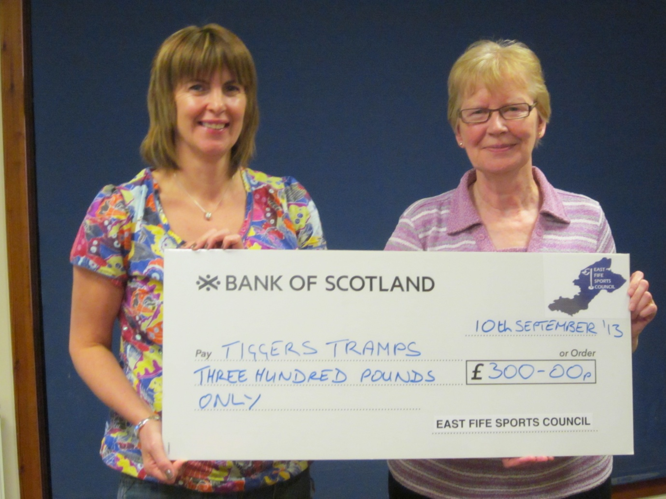

Mary Addison, on behalf of Tiggers Tramps, accepting £300 for team travel expenses to Birmingham
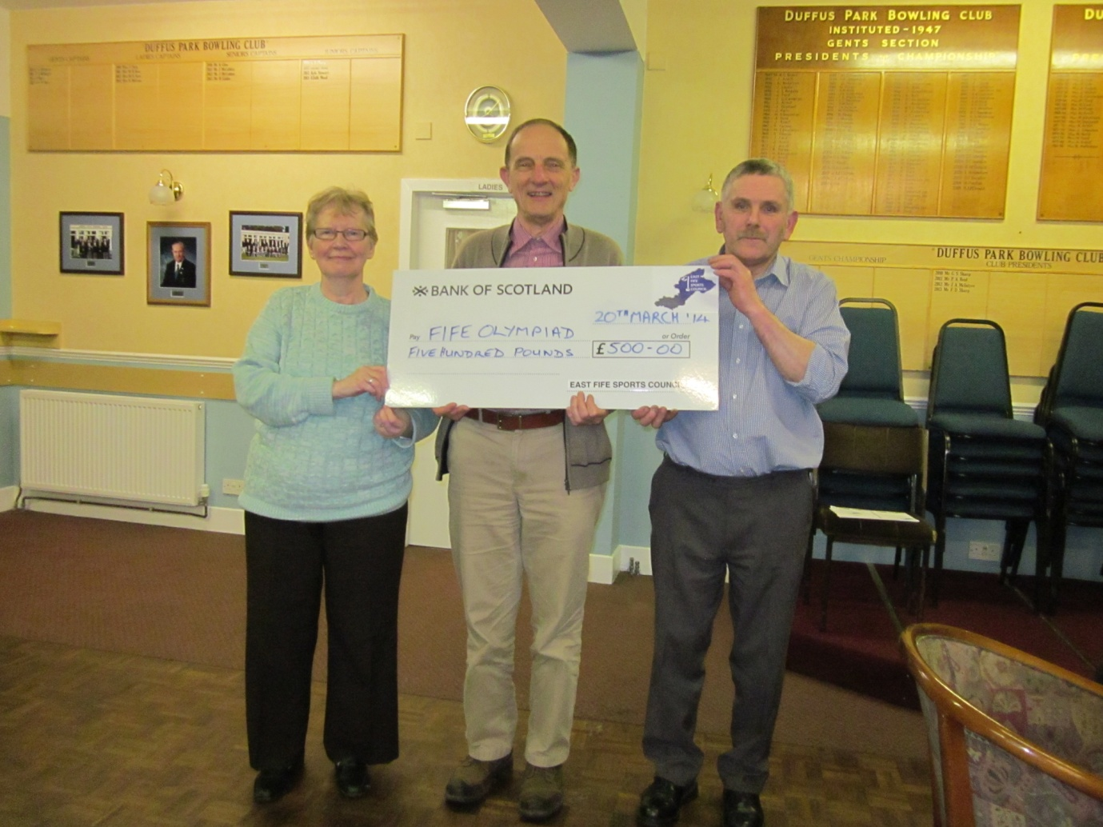

John Vaughan accepting £500 toward the Fife team travel expenses to Olympiad in Turkey
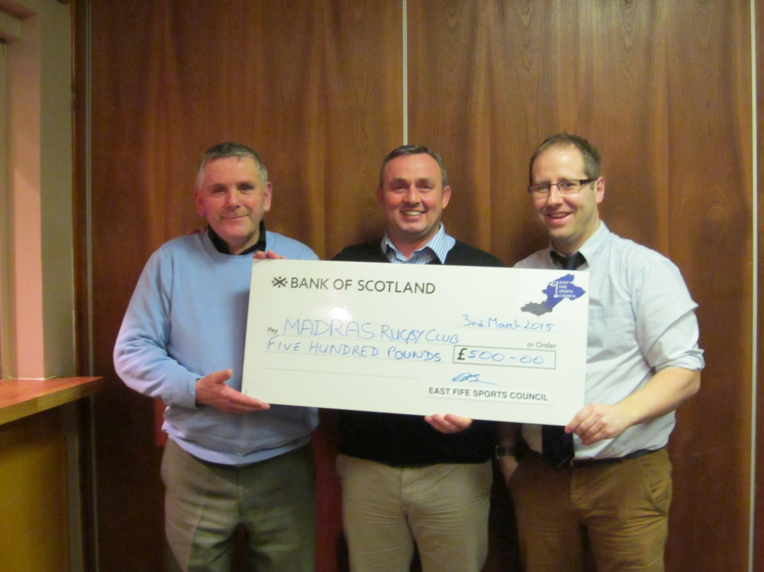
Madras Rugby Club Accepting £500 towards their Junior Training Camp
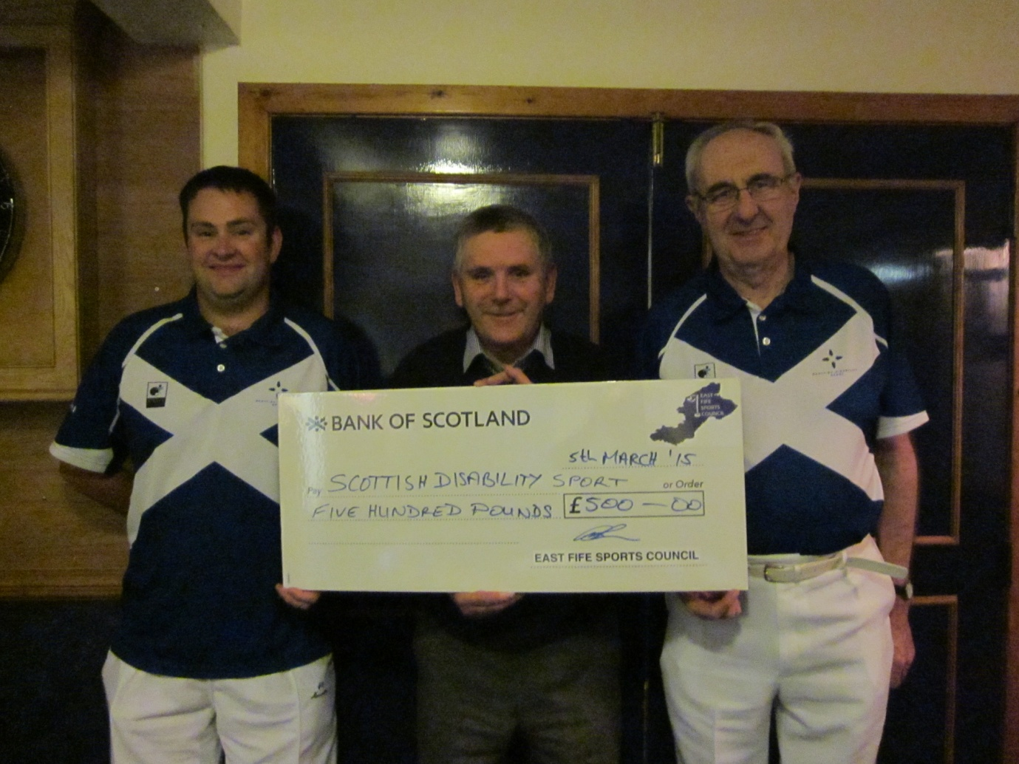

Bob Dick and Michael Simpson on behalf of Scottish Disability Sport accepting £500 towards team travel to New Zealand

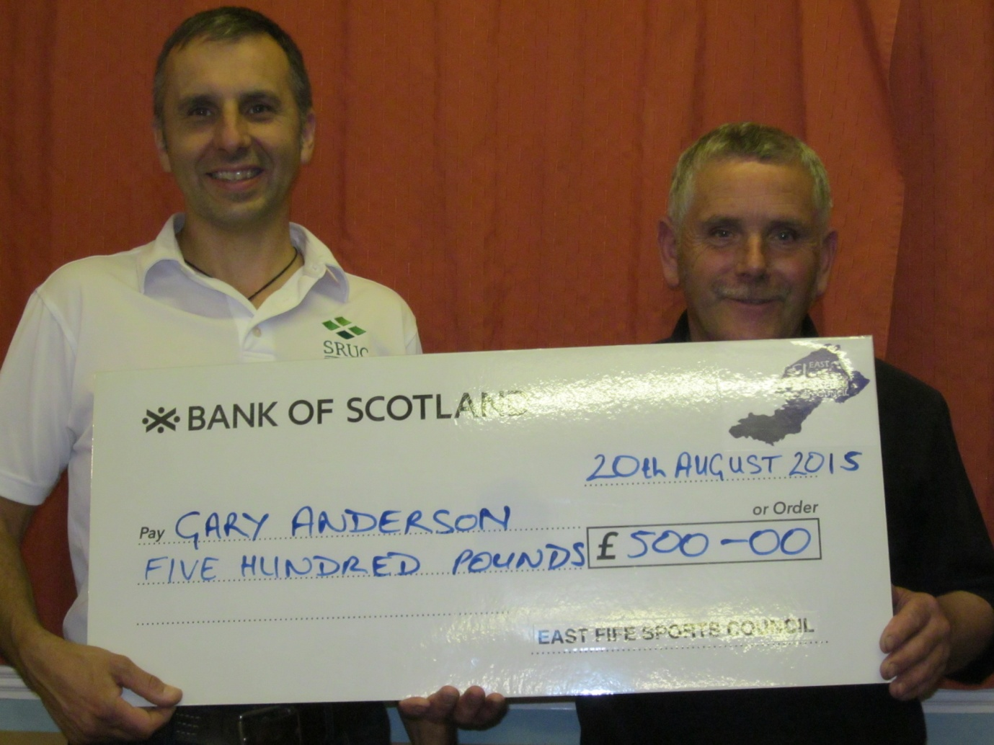
Gary Anderson of SRUC accepting £500 towards coaching/seminar fees.

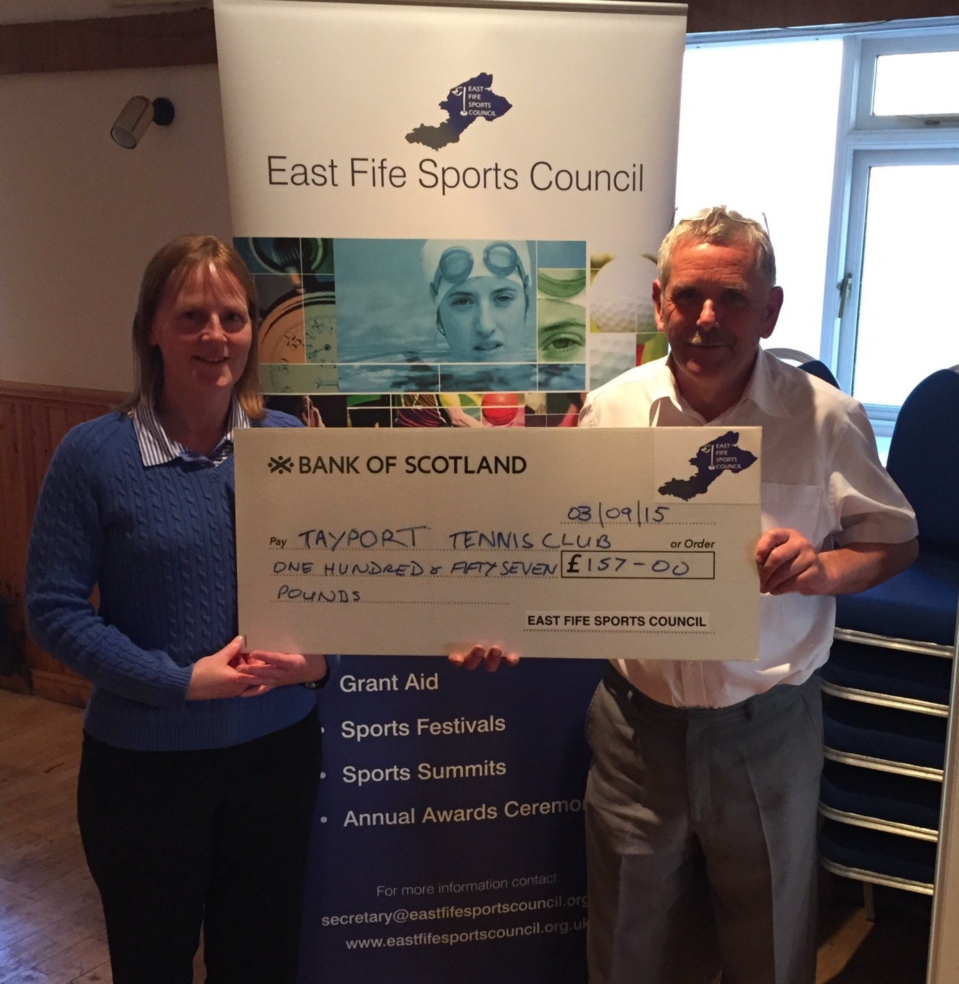
On behalf of Tayport Tennis Club Mandy Strachan accepting £157 towards their Junior tennis programme

